Tutorial -10 (15-10-2026)
1.A college maintains the marks obtained by students in a programming examination.
Develop a Python program using functional programming concepts to:
a) Identify students who scored 50 marks or above using filter().
b) Award 5 grace marks to every student using map(), ensuring that the maximum mark does not exceed 100.
c) Calculate the total marks using reduce().
d) Explain how lambda functions simplify the implementation.

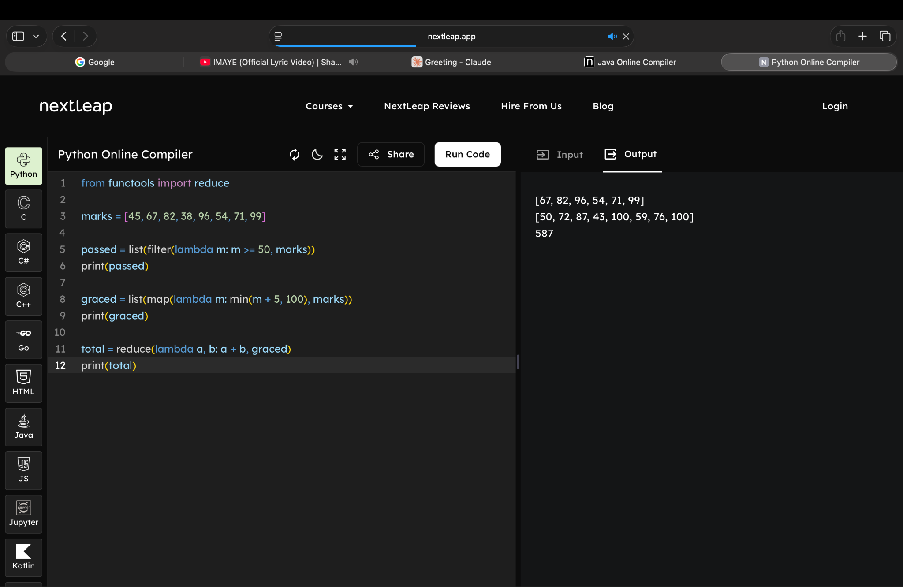
A lambda is a small unnamed function written inline. filter(), map() and reduce() each need a short rule. A lambda lets you write that rule right where it is used, so you don’t need a separate def for each one. This makes the code shorter and easier to read.

2. A company maintains the monthly salaries of its employees.
The company decides to provide a 10% salary increment to employees earning below ₹40,000.
a) Develop a program using map() and lambda functions to revise the salaries.
b) Use filter() to identify employees eligible for the increment.
c) Calculate the total salary expenditure after revision.
d) Explain why functional programming is suitable for processing salary records.

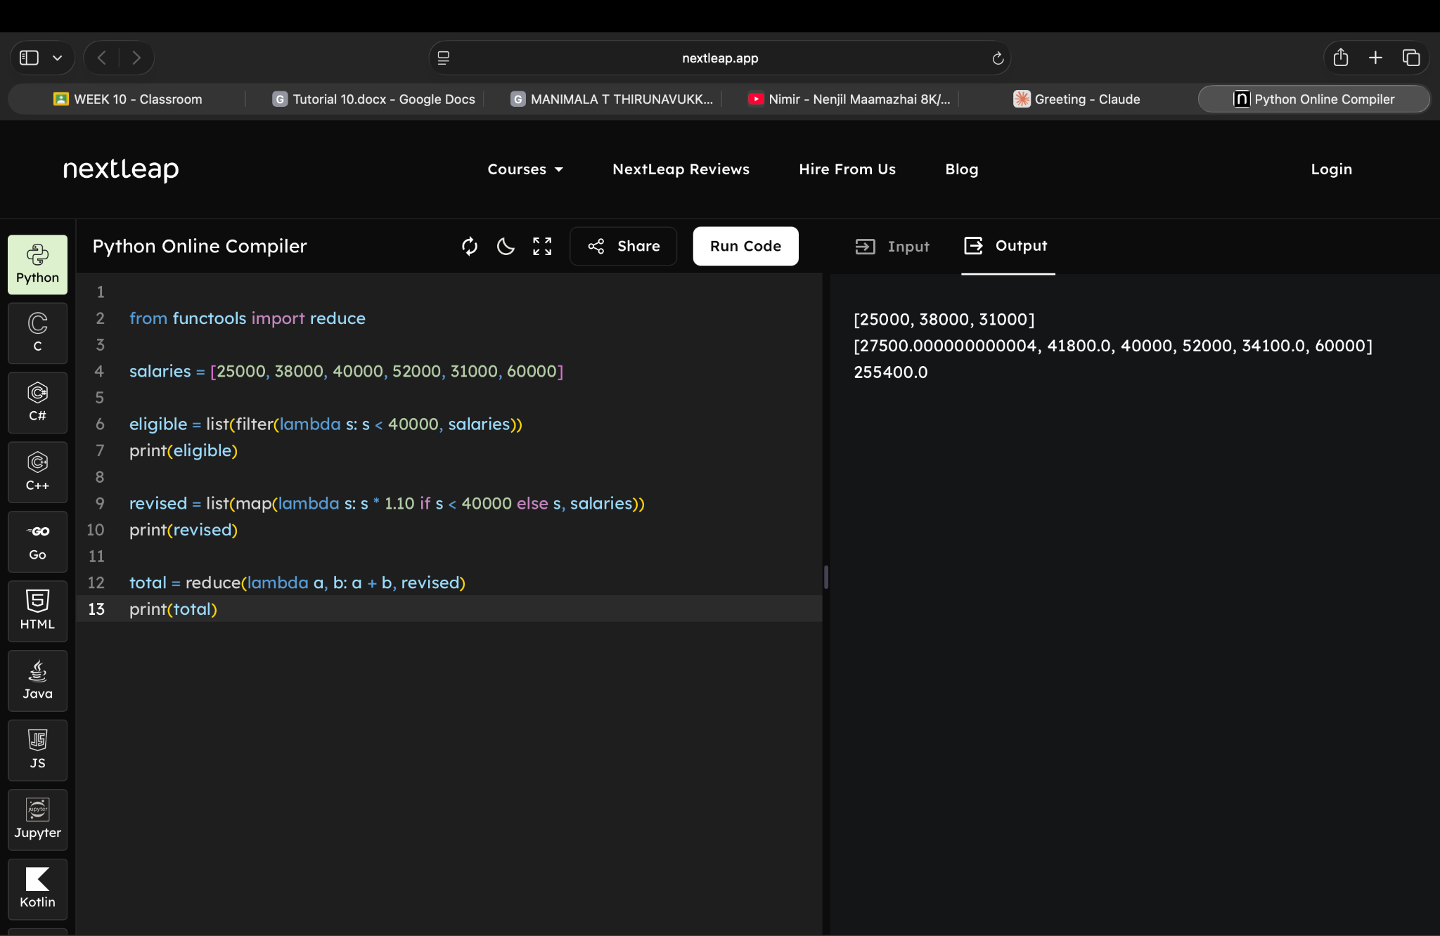

3. An e-commerce platform maintains a list of product prices.
During a festival sale, the company offers a 20% discount on products costing more than ₹1,000.
a) Write a pure function to calculate the discounted price.
b) Use map() to apply the discount to eligible products.
c) Use filter() to identify products costing more than ₹1,000.
d) Explain how the pure function avoids modifying the original product list.
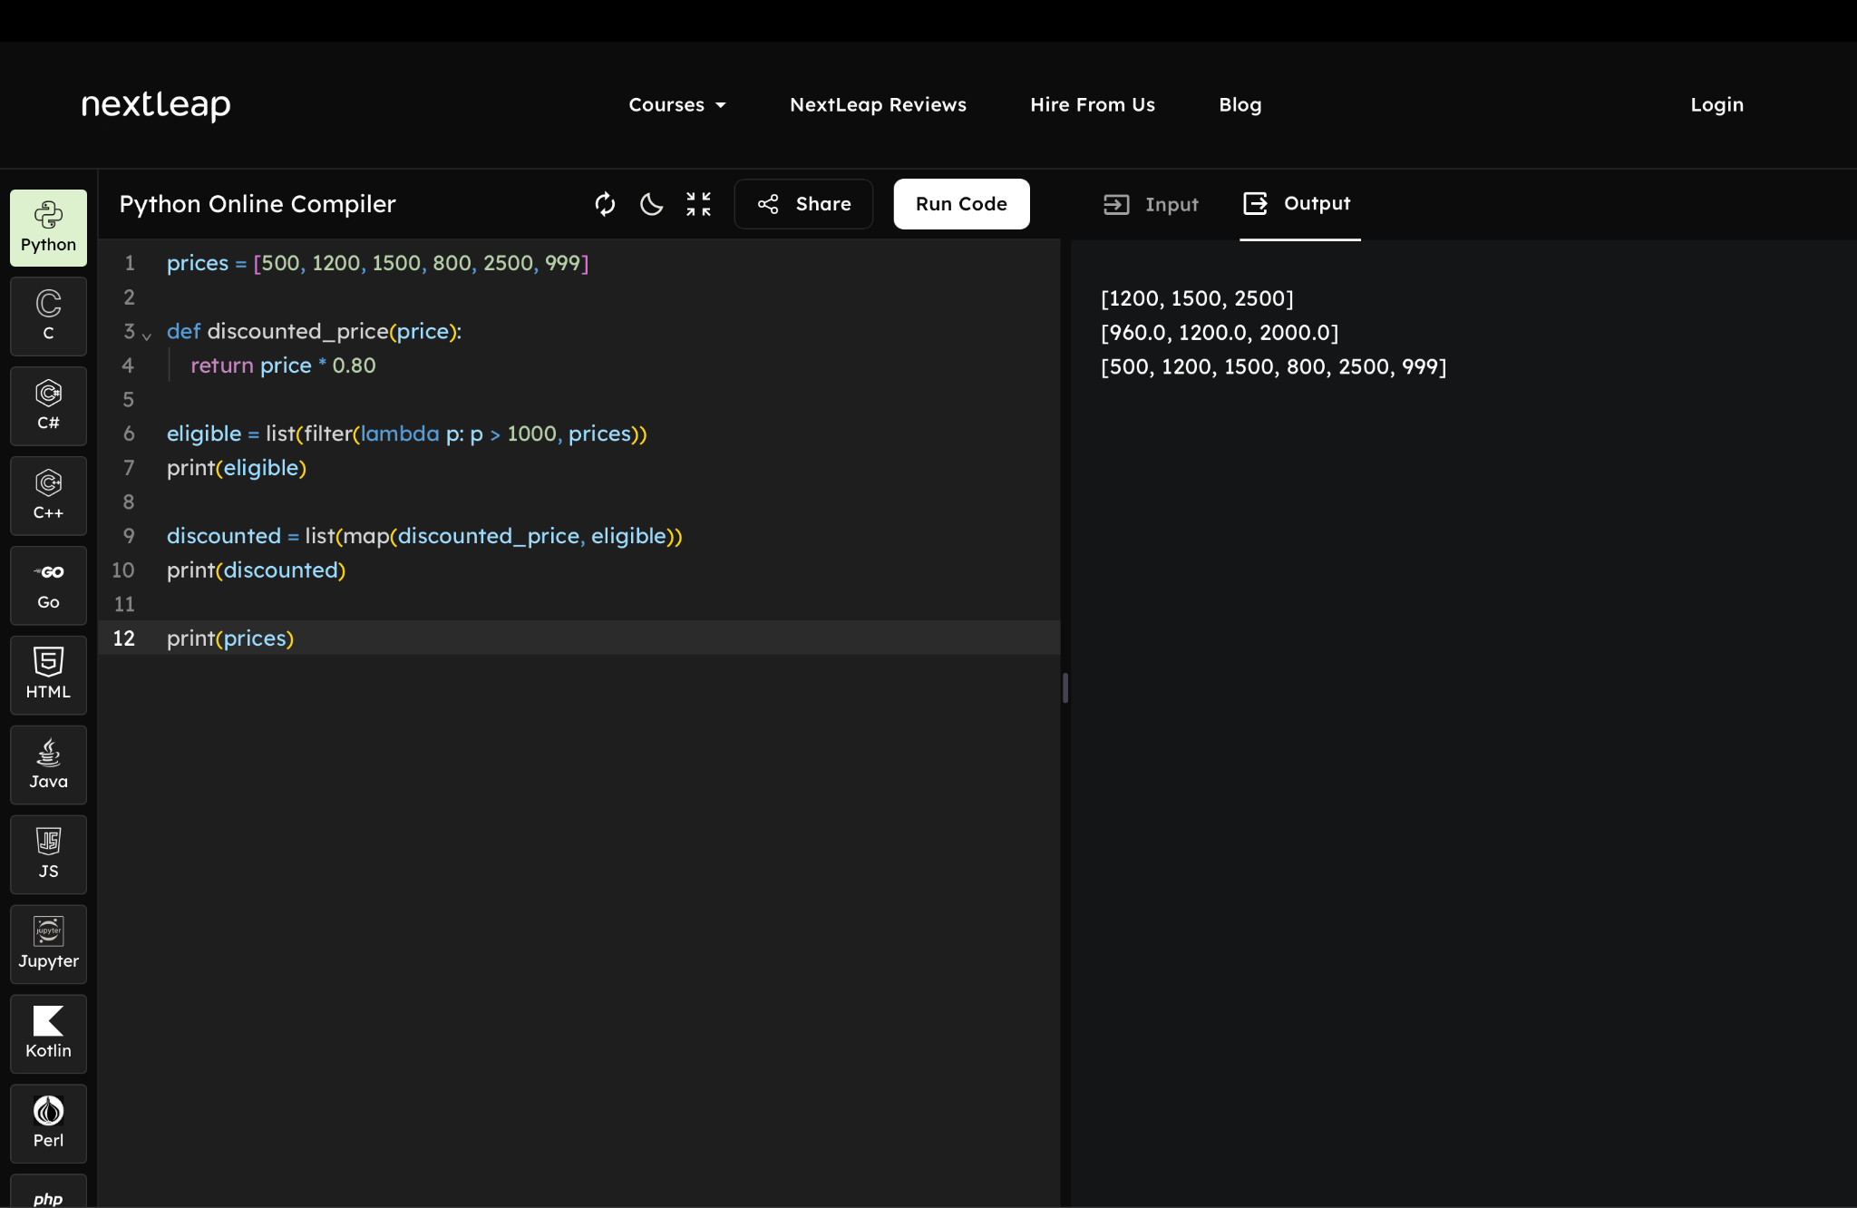

4. A smart electricity meter records the daily electricity consumption of a household.
a) Use filter() to identify days when consumption exceeded 10 units.
b) Use map() to calculate the electricity cost for each day at ₹6 per unit.
c) Use reduce() to determine the total electricity consumption.
d) Develop a pure function to calculate the electricity bill without changing the original consumption data.
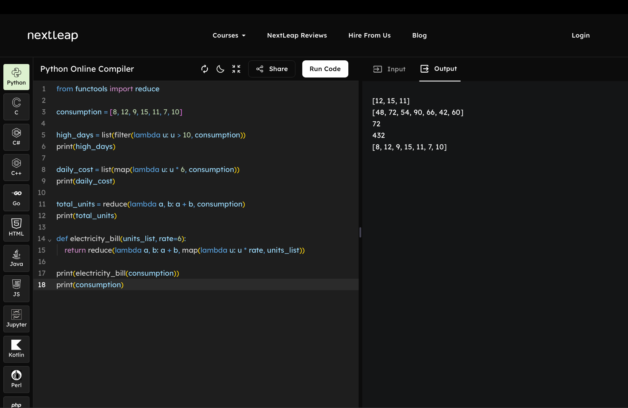

5. A university permits students to register for an advanced programming course only if they have passed Python Programming and Data Structures.
The following facts are available:
Student | Python | Data Structures
Arun | Pass | Pass
Bala | Pass | Fail
Charan | Pass | Pass
Divya | Fail | Pass
a) Represent the student results using logical facts.
b) Define a rule to determine eligibility for the advanced programming course.
c) Write a query to identify all eligible students.
a)passed(arun, python).
passed(arun, data_structures).

passed(bala, python).
failed(bala, data_structures).

passed(charan, python).
passed(charan, data_structures).

failed(divya, python).
passed(divya, data_structures).

b)eligible(S) :- passed(S, python), passed(S, data_structures).
c)?- eligible(S).
Output:
S = arun ;
S = charan;

6. An organization considers employees for promotion based on the following conditions:
- Minimum five years of experience.
- Completion of mandatory training.
- Performance rating of at least 4.
Employee | Experience (Years) | Training | Rating
Ravi | 6 | Completed | 5
Priya | 3 | Completed | 4
Kumar | 8 | Not Completed | 5
Meena | 7 | Completed | 4
a) Represent the employee information as logical facts.
b) Define a logical rule for promotion eligibility.
c) Write a query to retrieve employees eligible for promotion.
a)employee(ravi, 6, completed, 5).
employee(priya, 3, completed, 4).
employee(kumar, 8, not_completed, 5).
employee(meena, 7, completed, 4).
b)promotion(E) :- employee(E, Exp, Training, Rating),
Exp >= 5,
Training = completed,
Rating >= 4.

c)?- promotion(E).
output:
E = ravi ;
E = meena.

7. A shopping mall uses a rule-based parking allocation system.
The following parking spaces are available:
Slot | Vehicle Type | Availability
S1 | Car | Available
S2 | Bike | Occupied
S3 | Car | Available
S4 | Bike | Available
S5 | Car | Occupied
a) Represent the parking slot details using facts.
b) Define a rule to identify available parking slots for a particular vehicle type.
c) Write a query to retrieve available car parking slots.

a)slot(s1, car, available).
slot(s2, bike, occupied).
slot(s3, car, available).
slot(s4, bike, available).
slot(s5, car, occupied).

b)available_slot(S, Type) :- slot(S, Type, available).
c)?- available_slot(S, car).
Output:
S = s1 ;
S = s3.

